CS211 Model Solution.

Final Examination Spring 2018.

(1) The director did not lie to the applicant. For A implies B statement, if A is false, and B is true then the implication is true. **(5 marks)**

---------------------------------------------------------------------------------------------------------

(2) 12*2+1 = 25. Explain how the answer was obtained using the pigeonhole principle. **(5 marks)**

---------------------------------------------------------------------------------------------------------

(3) p1=1.5

p2= 1C1*p1=1.5

p3=2C1*p2+2C2*p1=4.5

p4=3C1*p3+3C2*p2+3C3*p1=19.5

delta_2=4C2*p2=9

delta_3=4C3*p3=18

delta_4=4C4*p4=19.5

beta = 9+18+19.5=46.5

Psedudo code

p[1] = 1.5

for (int t=2; t<=K; t++) {

for (int s=1; s<=t-1; s++) {

p[t] += Combination (t-1,s) *p[s];

}

}

for (int t=2, t<=K; t++) {  
 sum += Combination(K,t) * p[t];

}

double combination (int q, int r) **(10+5 marks)**

---------------------------------------------------------------------------------------------------------

(4) (a) The student need to show the idea of base step (2 marks) and induction step (3 marks), and show some working (2 marks). Due to the difficulty of the problem, we will be lenient when awarding marks for working.

(b) Proof by contradiction: lets assume that n is not an even number, then n can be expressed as follow:

n=2t+1,

Taking square of both sides we get

n2=4t2+4t+1

But due to the presence of the +1 term, n2 can not be even, hence leading to a contradiction. This only proves implication not biimplication. (3 marks)

To obtain the full 4 marks, the following answer will be accepted.

We can now prove the converse. If n2 is not even, then it can be written as,

n2=4t2+4t+1

but as shown earlier, a square root of this number is an odd number, hence leading to contradiction.

**(7+4 marks)**

---------------------------------------------------------------------------------------------------------

(5)20C5 – 12C5 – 8C5 = 14656

Or consider all the following 4 possibilities

1F & 4M : 8C1x12C4=3960

2F & 3M : 8C2x12C3=6160

3F & 2M : 8C3x12C2=3696

4F & 1M : 8C4x12C1=840

TOTAL 14656

The idea of tree: Show that the root will represent male, and the second leaf female (or vice versa).

**(6+3 marks)**

---------------------------------------------------------------------------------------------------------

(6) A description...

**(3+5+2=10 marks)**

---------------------------------------------------------------------------------------------------------

(7)

j=1, x=5, y=15, IF (false), Else if (true), c=32

j=2, x=23, y=1855, IF (false), Else if (true), c=1933

j=3, x=10829, y=5.266x10^10, IF (true), c=-5.26599x10^10

j=4, x=1.22x10^16 y=6.344x10^43, IF (true), c=-6.6344x10^43

**(8+2=10 marks**

(8)

(a) r → q xor not (s), or also r → q or not (s)

(b) ( not (s) and not (r) ) → q

(c) a proposition p always has the truth value T, regardless of the truth values of its components, in which case it is called a tautology. Example: p or (not) p.

**(2+2+2=6 marks)**

---------------------------------------------------------------------------------------------------------

9)

A description...

A description...

**(3+4=7 marks)**

---------------------------------------------------------------------------------------------------------

10) **(2x6=12 marks)**

(a) there exist x, s.t. q(x)

(b) there exist x, s.t. q(x) and p(x)

(c) q(x) 🡪 not (t(x))

(d) for all values x, s.t. q(x) and not (t(x))

(e) there exist, x, s.t. q(x) and t(x)

(f) q(x) and r(x) 🡪 s(x)

---------------------------------------------------------------------------------------------------------

11) **(3x3=9 marks)**

1 marks for the Venn diagram, 1 marks for correct answer, 1 marks for showing the working.

(a)

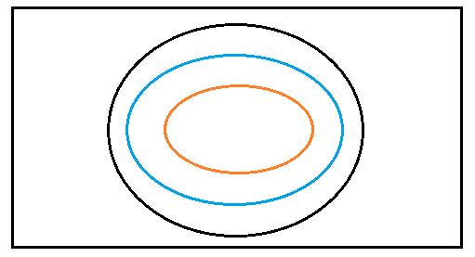

|A∪B∪C| = 5000

(b)

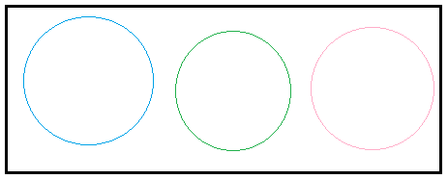

|A∪B∪C| = 5000+50+500 = 5550.

(c)

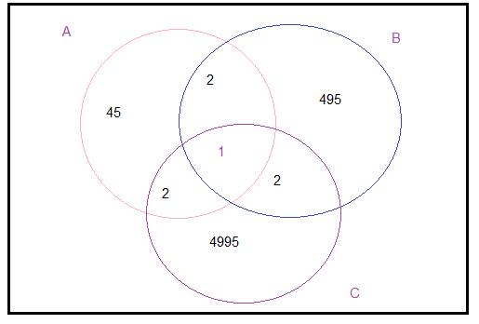

|A∪B∪C| = 5000+50+500 = 5542

---------------------------------------------------------------------------------------------------------

12) **(2x4+3=11 marks)**

A\ (A intersection B) U (A intersection C) is not a subset of the universal set

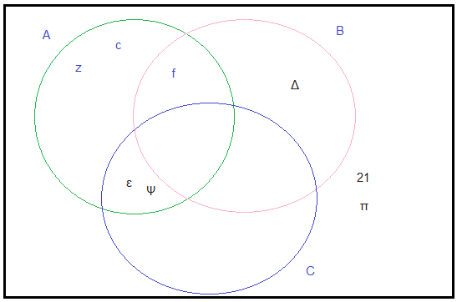

1. Bc **∩**U ={ ε, Ψ, 21, π }
2. Yes, can be seen from Venn diagram
3. Yes, because all elements of C are present in C.
4. Yes, because all elements of C are in A

(AUB) x C = {1, f, t, 8, 6, 5, pi} x {97, J, Y} -🡪 There will be 21 elements.

(AxC) U (BxC) 🡪 AxC will have 15 elements,

BxC will have 5 elements.

---------------------------------------------------------------------------------------------------------

13) **(4+4+4+3+3=18 marks)**

(a) Q has 7 edges

L has 6 edges

W has 8 edges

Z has 7 edges

So we have to test whether Q and Z are isomorphic or not?

For Q,

Degree (b)=2, degree (c)=4, degree(d)=2, degree (a)=3, degree (e)=3

For Z,

Degree(u)=2, degree(s)=4, degree(t)=2, degree (r)=3, degree (q)=3

The results are intuitive due to symmetry of graph Q. An answer showing bijection will also be considered.

(b) Any connected path with total weight of 4 will be accepted.

(c) perform an exhaustive search with the 24 possibilities (4!).

(d) G=[{p,o,k,l,m,n}, { {p,k}, {k,l}, {p,l}, {l,o}, {l,m}, {m,o}, {m,n}, {o,n} }]

(e)Quadratically increasing memory overhead

---------------------------------------------------------------------------------------------------------

14. **(3+2+3+4=12 marks)**

(a) drives ={ (Anne, Mini), (Bert, Polo), (Charlie, Polo), (Diane, Capri), (Diane, Clio)}

(b)

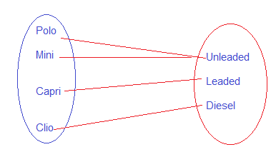

(c)

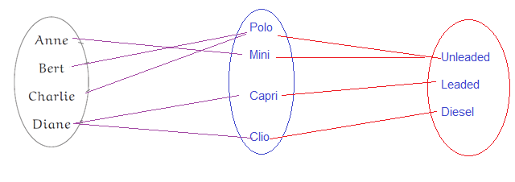

(d) A employee_of B AND B Status Public_company

---------------------------------------------------------------------------------------------------------